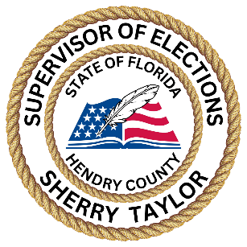
Hendry County
Sherry Taylor, Supervisor of Elections
Petition Status Report
 |  | 12/29/2023 |  |  | F.S. 100.371(11)(c)
 | Initiative Petition | Total # of Petitions Received | Total # Valid by Congressional District 18 | Total # Signatures Verified Valid | Total # Verified Petitions Submitted to State
14-02 | Limits or Prevents Barriers to Local Solar Electricity Supply | 0 | 0 | 0 | 0
18-16 | Provide Medicaid Coverage to Eligible Low-Income Adults | 0 | 0 | 0 | 0
21-17 | Legalizes Personal Use Marijuana for Adults Twenty- One or Older, Permits Adults to  Cultivate Marijuana. | 1 | 1 | 1 | 1
22-01 | Prayer Back in Schools | 4 | 3 | 3 | 4
22-05 | Adult Personal Use of Marijuana | 1,009 | 689 | 689 | 1009
23-07 | Amendment to Limit Government Interference with Abortion | 723 | 454 | 454 | 723

